Mathematics Worksheet: Consumer Arithmetic
Form Level: First 1st
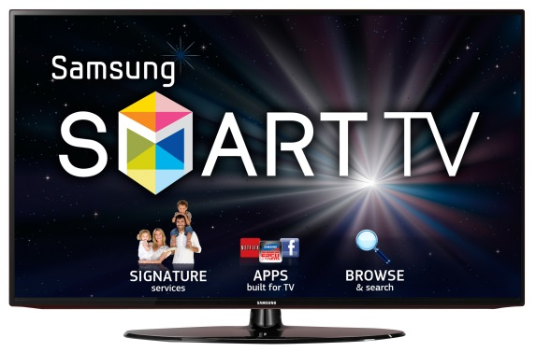

The cost of a SAMSUNG LED / 40-inch SMART television from a popular retail store in Bridgetown $\$2,900$ BDS. A similar television can be purchased from an online retail stores, Amazon or BESTBUY. You are required to select one of these retail online stores and compare the price of importing the television to the price of purchasing the television locally. To do this you will need to note the online price of the television and the weight (both rounded to the nearest whole number).
Select a television from only one of the following links to compare to the local price:
- BESTBUY http://www.bestbuy.com/site/samsung-50-class-49-5-diag--led-1080p-smart-hdtv-black/4405201.p?skuId=4405201

- Amazon https://www.amazon.com/Samsung-Class-1080p-Smart-Browser/dp/B01AC9E040/ref=sr_1_11?s=tv&ie=UTF8&qid=1484828812&sr=1-11&keywords=smart+TV+samsung

To accurately determine the price of importing the television you must consider the following:
- The US cost price and the weight (lbs) of the television you have selected must be stated. [2 marks]

- The online price of the television is quoted in US currency. Using an exchange rate of
$US\$1 =BDS\$2$, convert the US online price to Barbados currency to determine the purchase price. [2 marks]

- To ship the television to Barbados, a shipping company will determine the shipping cost based on the weight of the item to be shipped. The rate for shipping is Bds $20 per lb plus an additional Bds $30 is added as a handling fee. Determine the total shipping cost. [4 marks]

- Duties must be paid on all non-PC electronic products imported. The government of Barbados charges 60% of the purchase price of the television (shipping cost not included), which must be paid when it arrives in the island. Determine the amount of duties to be paid. [3 marks]

- Using all previous calculations, determine the total importation cost. [3 marks]

You are required to compare the local price to the total importation cost, the risk involved, the time and effort needed to do both, and write a detailed summary to determine, in your opinion, whether it is wiser to purchase the television locally or from the online store you selected. [6 marks]

