**1.**



Diagram  **NOT** accurately drawn

The diagram shows a circle, centre *O.  
A, S, B* and *T* are points on the circumference of the circle.

*PT* and *PS* are tangents to the circle*.  
AB* is parallel to *TP.*

Angle *SPT* = 44°.

Work out the size of angle *SOB.*

..................................°

(Total 4 marks)

**2.**



*A*, *B*, *C* and *D* are four points on the circumference of a circle.  
*ABE* and *DCE* are straight lines.

Angle *BAC* = 25°.

Angle *EBC* = 60°.

(a) Find the size of angle *ADC*.

.........................°

(1)

(b) Find the size of angle *ADB*

.........................°

(2)

Angle *CAD* = 65°.  
Ben says that *BD* is a diameter of the circle.

(c) Is Ben correct? You must explain your answer.

.............................................................................................................................................

.............................................................................................................................................

(1)

(Total 4 marks)

**3.**



Diagram **NOT** accurately drawn

*T*, *A* and *B* are points on the circumference of the circle, centre *O*.  
*AT* is a diameter of the circle.  
Angle *BTC* = 40°  
Angle *TAB* = 30°

Explain why *TC* cannot be a tangent to the circle.

…………………………………………………………………………………………

…………………………………………………………………………………………

…………………………………………………………………………………………

…………………………………………………………………………………………

(Total 2 marks)

**4.**



Diagram **NOT** accurately drawn

The diagram shows a circle centre *O*.  
*A*, *B* and *C* are points on the circumference.

*DCO* is a straight line.  
*DA* is a tangent to the circle.

Angle *ADO =* 36°

(a) Work out the size of angle *AOD*.

................................. °

(2)

(b) (i) Work out the size of angle *ABC*.

................................. °

(ii) Give a reason for your answer.

...............................................................................................................................

(3)

(Total 5 marks)

**5.**



Diagram **NOT** accurately drawn

*A* and *B* are two points on the circumference of a circle, centre *O*.  
*TA* is a tangent to the circle.  
Angle *BOA* = 104°.

Work out the size of angle *BAT*.

.......................°

(Total 3 marks)

**6.**



Diagram **NOT** accurately drawn

*T* and *S* are points on the circumference of a circle.  
*PT* and *PS* are tangents to the circle.  
Angle *STP* = 52.  
Angle *TPS* = *x*.

(i) Work out the value of *x*.

*x* = ................................

(ii) Give reasons for your answer.

................................................................................................................................................

................................................................................................................................................

................................................................................................................................................

(Total 2 marks)

**7.** *R*, *S* and *T* are points on the circumference of a circle, centre *O*.  
*PS* and *PT* are tangents to the circle.  
*PSN* and *TORN* are straight lines.  
*PO* are parallel to *SR*.  
*SR* = *NR*.  
Angle *OPT* = angle *OPS*.



Diagram **NOT** accurately drawn

(a) Work out the size of angle *PNT*.

……………………………

(3)

(b) Show that *PS* = *SN*.

(3)

(Total 6 marks)

**8.**



In the diagram, *A*, *B* and *C* are points on the circle, centre *O*.  
Angle *BCE* = 63°.  
*FE* is a tangent to the circle at point *C*.

(i) Calculate the size of angle *ACB*.  
Give reasons for your answer.

...............................°

(ii) Calculate the size of angle *BAC*.  
Give reasons for your answer.

...............................°

(Total 4 marks)

**9.**

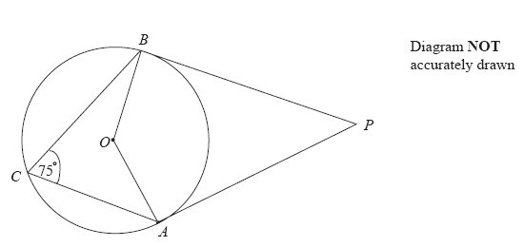

In the diagram, *A*, *B* and *C* are points on the circumference of a circle, centre *O*.

*PA* and *PB* are tangents to the circle.

Angle *ACB* = 75°.

(a) (i) Work out the size of angle *AOB*.

…………………….°

(ii) Give a reason for your answer.

………………………………………………………………………………………..

………………………………………………………………………………………..

(2)

(b) Work out the size of angle *APB*.

…………………….°

(3)

(Total 5 marks)